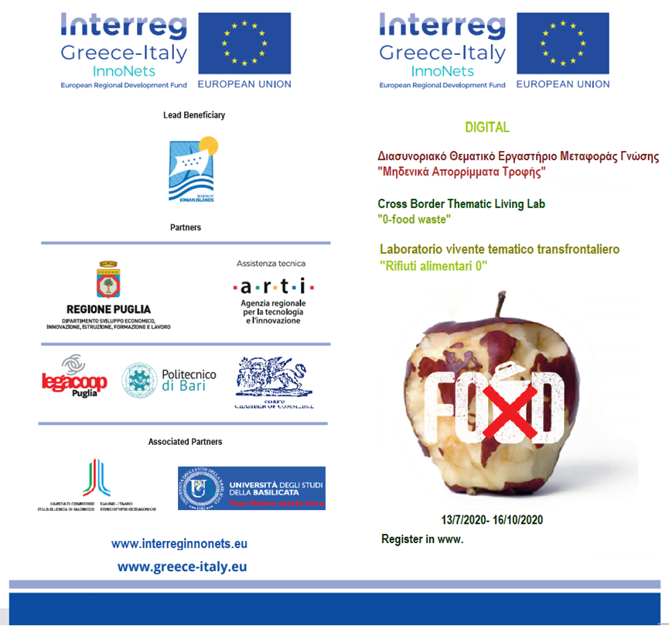

Structural prevention of food waste: technologies for sustainable production
“Onlife” Meeting

07 October 2020 – Time: 15:00 - 17:00
on Zoom platform

Agenda:

15.00 – 15.20 | Welcome addresses
 | Gaetano Grasso , InnovaPuglia SpA
 | Crescenzo Antonio Marino*, Apulia Region, Director, Research, Innovation and Institutional Capacity Section
15.20 – 15.30 | The mindfulness food lab: Sharefood project
 | Gerardo Centoducati University of Bari
 | Valentina Zacchino – Gruppo Megamark srl/Federico Villani Consea srl
15.35 – 15.45 | The aging food lab: Altis project/ Simms Project
 | Angelica Miccolis Farmalabor srl
 | Pietro Siciliano CNR IMM/Francesco Ciliberti Intellego srl
15.50 – 16.00 | The food of future lab: Ohmics4Food Project
 | Francesca De Leo CNR IBIOM/Maria De Angelis University of Bari/Stefano Potenza Essenza Glutine
16.05-16.15 | The traceable food lab: Good for you! Project
 | Pietro Siciliano CNR IMM
16.20-16.30 | The functional food lab: Innotipico Project
 | Andrea Minisci – Vallefiorita srl
16.35-16.45 | Discussione
16.45-17.00 | Conclusioni – Valeria Patruno ARTI/Alessandro Bonifazi Politecnico of Bari/Katia De Luca LegaCoop

Topics details:
Structural prevention of food waste: technologies for sustainable production
The United Nations formulated the Sustainable Development Goals (SDGs) in 2015 as a comprehensive global policy framework to address the most pressing social and environmental challenges facing humanity today. In this document we start from SDG 12, which aims to "guarantee sustainable production and consumption models" for a systemic approach to the structural prevention of food waste. In fact, it is necessary to pursue the transformation of consumption and production systems as a lever for achieving multiple sustainability objectives, including the fight against food waste.
The rationale of a thematic living lab on local food policies could meet the target of food waste reduction if we stimulate a social/technological innovation strategy oriented to a conscious consumption able to avoid food waste both in the market chain and in the household economy. In fact the match between technology innovation and social innovation could determine scaling up of living lab approach of overall the functional food production, scaling out of the living lab experience through the Greece-Italy project Innonets sharing the common good of Mediterranean Diet and scaling deep to impact cultural roots, values and beliefs of regional agrifood sector thanks to biotechnologies. It means that the outcomes of the living lab could contribute to a circular economy strategy able to increase employement through new high tech professional skills in a traditional sector as well as agrifood one and agricultural valorization of traditional cultivar through their application as raw materials in new functional food.
The mindfulness food lab
According to an FAO study entitled "Global Food Losses and Food Waste" (2011), more than a third of the food produced each year for human consumption is lost or allowed to expire (about 1.3 billion tons: 670 from industrialized countries and 630 from developing countries). The leading role in this "process" is played from industrialized countries and estimates show that Europe alone wastes 89 million tons of food per year (an average of 180kg per capita). The greatest waste is recorded in the Netherlands with 579kg per capita and in Italy, although far from such levels of waste, it still represents one of the leading countries in this ranking with its 149kg pro understand. The phenomenon of food waste has reached dramatic dimensions and assumes even more importance considering that more than a billion people suffer from hunger and that about 24,000 people die from it every day. This problem affects our lives ever more closely and highlights the responsibility of every citizen: “In Europe, 42% of food waste occurs within the walls of the house "explains Francesco Mele, manager the Slow Food Italia campaign against food waste; and according to Adam Rein (report contributor of MissionPoint Partners) "About 85% of food waste occurs in homes and restaurants" 2. These data prompted Consea srl, Softline srl, Nisi & C. Synthesy soc.coop.soc., Bonassisa Lab srl, Megamark srl, together with the University of Bari as a Research Body that supports companies in grouping with the two departments of Emergency and Organ Transplantation (DETO) and of Soil, Plant and Food Sciences (DiSSPA), to respond to the needs emerged from the Living Lab Catalog similar to the theme of surplus food. The beneficiaries want to create a co-design path of a solution that aims 1) The creation of a permanent network of solidarity made up of institutions, organizations, associations, profit and non-profit enterprises profit, donors with a view to developing the Smart City & Community; 2) the reduction of food surplus as an implementation action of the Gadda Law (Law no. 166 of 19/08/2016) and in relation to the prevention objectives e reduction of waste production with social purposes aimed at guaranteeing food support to disadvantaged categories, and 3) to sensitize consumers to health issues and so may make him aware of his food choices.

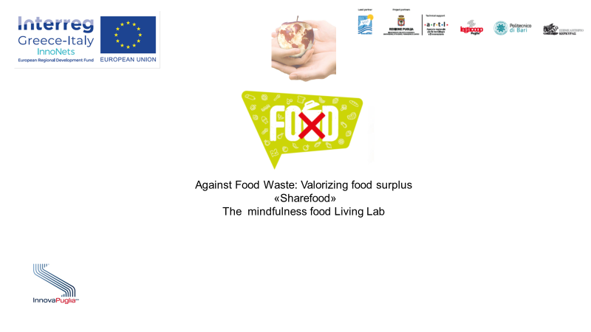

The food of future lab
The food of the future is not a science fiction suggestion but a real perspective in terms of new agrifood products. The -omics technologies such as genomics and proteomics could support producers in developing new nutraceutical foods for more sensitive and conscious consumers. Building up a living lab on the food of the future means to answer to the demand of healthy eating, particularly coming from frailer people considering the progressive aging of our societies. In Puglia region flour based foods represent an important production chain with some of the bigger Italian companies leader of the sector and a large number of SMEs involved. Proteomics and genomics applications could increase the quality of these flour based foods thanks to a research environment, fully equipped with operative platforms (Elixir - https://elixir-europe.org/) based on the most innovative NGS technologies and powerful resources for data storage and computational analysis. The CNR-IBIOM is in charge of the management of the Italian node of ELIXIR, leaded by CNR. To have a concrete idea of food of future just think about bread with a longer shelf life, it means a remarkable reduction of waste food and a better redistribution of surplus production to poor people, matching technology innovation with social innovation. Moreover, the living lab benefits of the support of University of Bari both in terms of high level of research methodologies of the Labs Network LAIFF and in terms of stakeholders networking with the involvement of the Food Hub of the European Institute of Innovation & Technology (EIT Food Hub).
From this point of view it is fundamental in terms of quadruple helix strategy to involve NGO in the living lab more than the stakeholders already involved, Apulian SMEs and CNR IBIOM. In fact these activities have been funded by Apulia Region project (ACRONYM OMICS4FOOD "Miglioramento nei processi produttivi di alimenti freschi prodotti da farine mediante approcci basati su tecnologie omiche ed informazioni complesse, elaborate da un sistema informativo progettato e sviluppato in ambiente Cloud") leaded by Eusoft with the parternship of EssenzaGlutine, PastaApulia, BasePizza, Food Safety Lab and CNR-IBIOM in collaboration with UniBa.

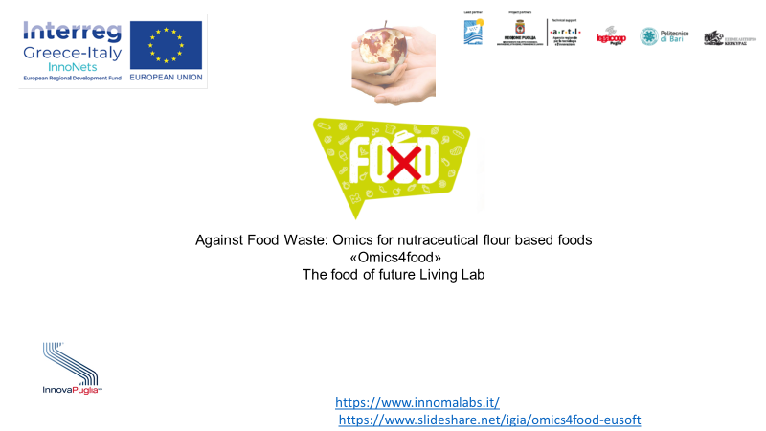

The aging food lab
Proper diet and a healthy life go hand in hand, especially for older adults over the age of 65. According to reports by World Health Organization (WHO), a majority of the diseases that older people suffer are as a result of lack of proper diet.

For instance, fat in food is linked cancer of the prostate, colon, and pancreas. Degenerative diseases such as osteoporosis and diabetes are also diet-related, more specifically with micronutrients.
Micronutrients deficiency is shared among the elderly due to factors such as reduced food intake and lack of variety in their diet.
elderly nutrition program
Carbohydrate-rich foods
Protein-rich foods
Fruits and vegetables
Senior citizens are an interesting target group for manufacturers, government bodies and information services. There are plenty of market opportunities and health benefits can be gained by preventing malnourishment in the elderly, for example. The main challenge for manufacturers, government bodies and information services is to design products that meet the specific needs and requirements of this target group, which include tackling loneliness, improving physical performance and producing nutritious food that also tastes good. The nutritional status and exercise habits of elderly people living at home are monitored using E-health tools. This allows healthcare professionals to intervene at the first sign of malnourishment and inactivity.

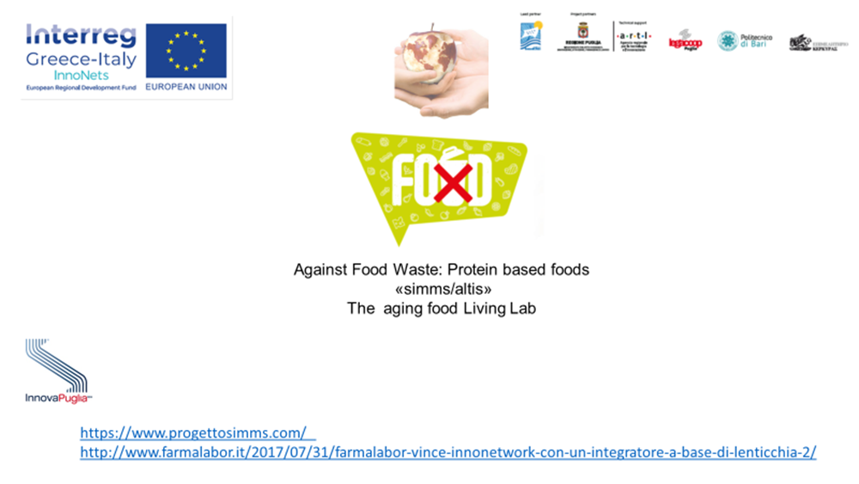

The traceable food lab
Food safety has been a growing concern among EU citizens over the last decades. Outbreaks of disease in animals that could be transmitted to humans, or the presence of chemicals above acceptable limits in feed and food, can threaten both the quality and safety of products. Traceability is a risk-management tool which allows food business operators or authorities to withdraw or recall products which have been identified as unsafe. It is a cornerstone of the EU’s food safety policy. Under EU law, “traceability” means the ability to track any food, feed, food-producing animal or substance that will be used for consumption, through all stages of production, processing and distribution. Tracing food and feed throughout the food chain is very important for the protection of consumers, particularly when food and feed are found to be faulty. The General Food Law Regulation defines traceability as the ability to trace and follow food, feed, and ingredients through all stages of production, processing and distribution.
Traceability:
• facilitates withdrawal of faulty food/feed from the market;
• provides consumers with targeted and accurate information on specific products;
• covers all food and feed, all food and feed business operators, without prejudice to existing legislation on specific sectors;
• affects importers who are required to be able to identify from whom the product was exported in the country of origin;
• obliges businesses to be able to identify at least the immediate supplier of the product in question and the immediate subsequent recipient, with the exemption of retailers to final consumers - one step back-one step forward.
It could be applied to food business operators at all stages of the food/feed chain, from primary production (food producing animals, harvests), food/feed processing to distribution and supply, including brokers, regardless of whether they take physical possession of the food/feed in question. This may also include charities, so that the living lab will include NGO in order to complete the stakeholders landscape on the traceability issue. 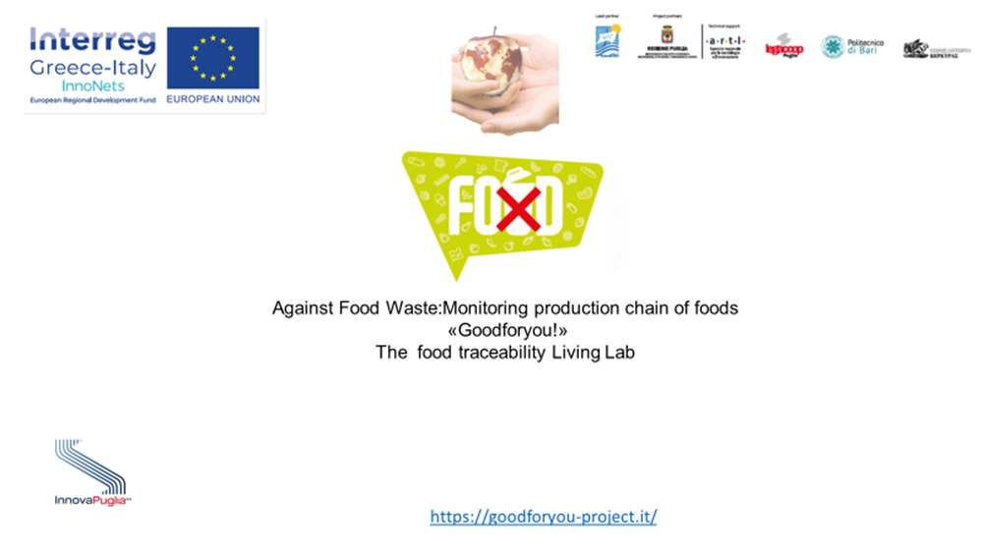
The functional food lab
In a food production chain, from a quadruple helix point of view, users are clearly the consumers and today their needs could be influenced by a behavioral approach based on taste pleasure instead of a cultural behavior oriented to healthy nutrition. So that a living lab strategy could nudge users behavior toward a more awareness in food shopping both from a nutritional perspective and a food waste reduction culture. The starting point is anyway the production process needing to innovate its organization both in terms of new products and in manufacture engineering able to integrate the facilities and systems for producing quality products with the optimum expenditure of capital. The manufacturing or production engineer's primary focus is to turn raw material into an updated or new product in the most effective, efficient & economic way possible. In the food production chain it means to valorize local agriculture products emphasizing their nutritional properties and organoleptic characteristics. In this direction biotechnologies represent the enabling key technology able to transform the food production chain toward healthy nutrition standard without forgetting our healthy eating tradition and culture in a circular economy perspective. This is the rationale of a functional food living lab that could meet the target of food waste reduction if together with the technological innovation we stimulate a social innovation strategy oriented to a conscious consumption able to avoid food waste both in the market chain and in the household economy. From this point of view the involvement of NGO in this living lab creation is fundamental for organizing the redistribution of surplus food. Companies, charities and individuals can all benefit from the redistribution of surplus food but it is necessary to orient this solidarity action toward healthy eating because people needing eating aid and food purchasing support are in the same time the frailer in terms of health. Last but not least the match between technology innovation and social innovation could determine scaling up of living lab approach of overall the functional food production, scaling out of the living lab experience through the interreg project Innonets and the partnership with Greece sharing the common good of Mediterranean Diet and scaling deep to impact cultural roots, values and beliefs of regional agrifood sector thanks to biotechnologies. It means that these outcomes of the living lab could contribute to a circular economy strategy able to increase wealth distribution through new high tech professional skills in a traditional production sector as well as agrifood one and agricultural valorization of traditional cultivar through their application as raw materials in new functional food.
